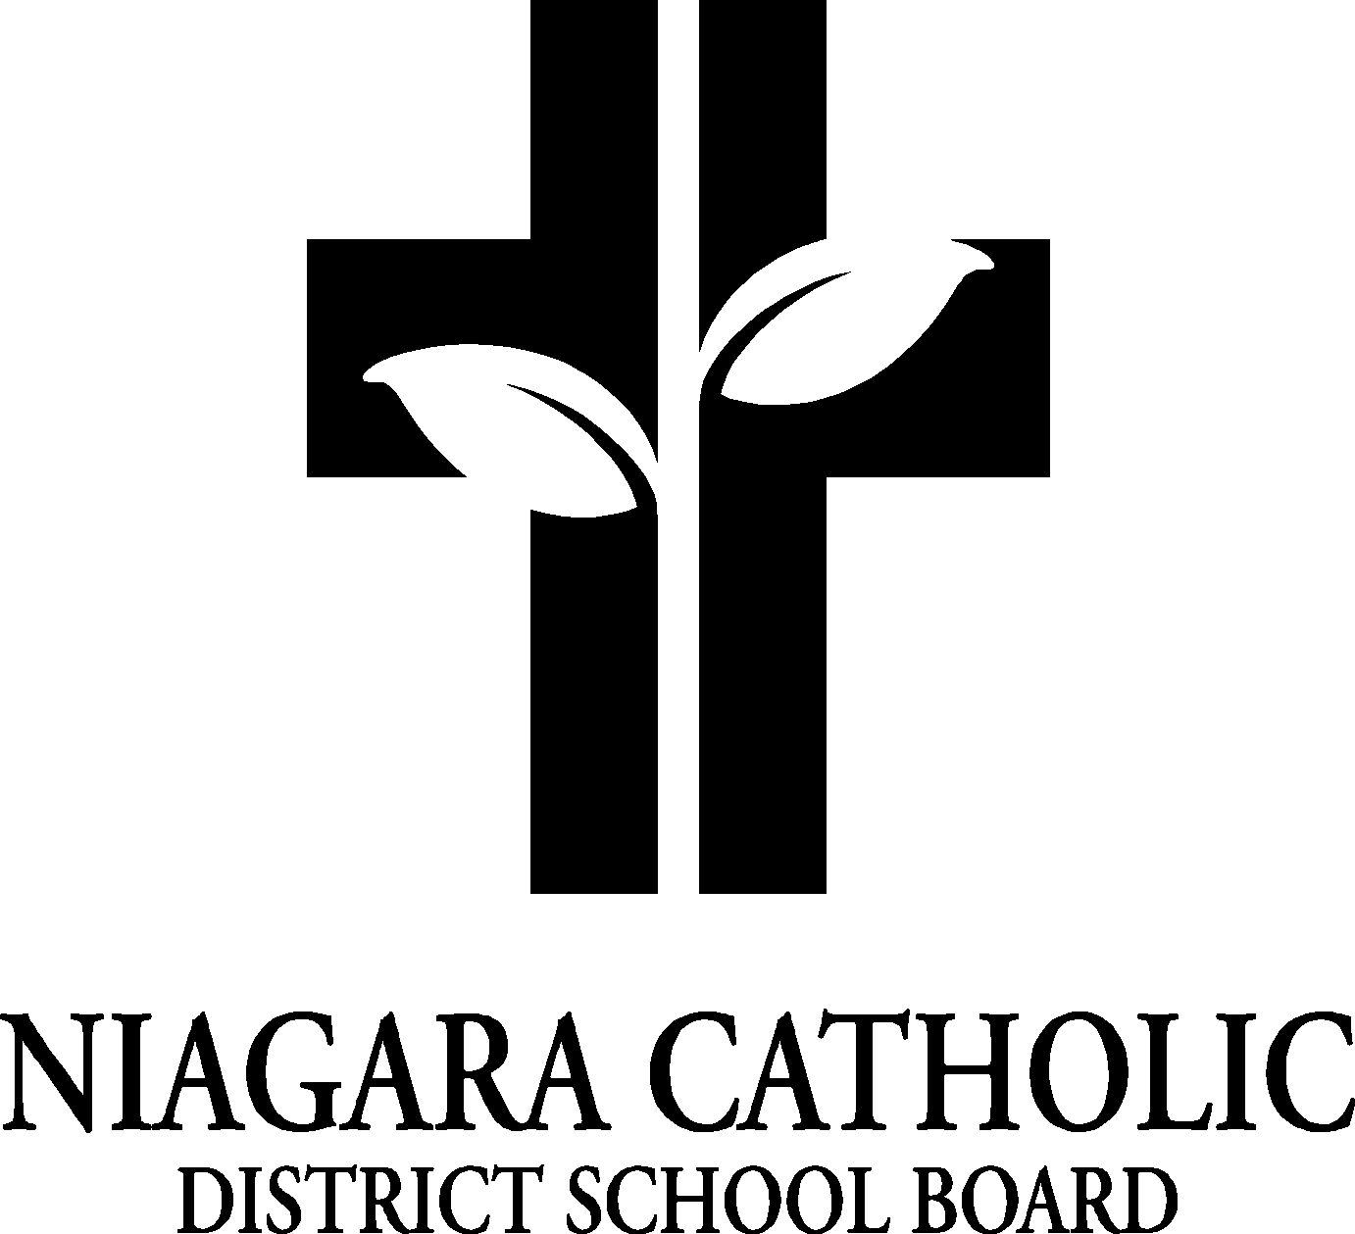

**AGENDA**

ST. PATRICK CATHOLIC

**CATHOLIC SCHOOL COUNCIL MEETING**

TUESDAY, Feb. 28th, 2022

VIRTUAL “GOOGLE MEET”

1. **ROUTINE MATTERS**
2. Opening Prayer
3. Roll Call
4. Approval of Agenda
5. Disclosure of Conflict of Interest
6. Approval of the Meeting Minutes of the St. Patrick Catholic School Council Meeting of Nov. 29h, 2021
7. **PRESENTATIONS: n/a**
8. **POLICIES FOR VETTING-Nothing to report**
9. **PRINCIPAL’S REPORT**
10. Niagara Catholic Parent Involvement Committee Report
11. Special Education Advisory Committee (SEAC) Report
12. Catholic School Council Financial Report : Mrs. Ricci will review
13. **OAPCE REPORT (**Ont. Assoc. for Parents in Catholic Education): Trish
14. **STAFF REPORT: Mrs. Villegas**
15. **AGENDA ITEMS-DISCUSSION FOR FUTURE MEETINGS**
16. **NEXT MEETING: May 16, 2022 at 6 p.m.**
17. **CLOSING PRAYER**
18. **ADJOURNMENT**

**Principal’s Report**

**Catholicity:**

* Ash Wednesday: Prayer service and Ashes (March 2)-at church
* Shrove Tuesday: March 1 (Nancy and Trish to support)-Knights of Columbus
* Lenten Activities in Classrooms during the 40 days of Lent
* First Holy Communion: Feb 27th and May 15
* Confirmation: Scheduled for April 30th
* Holy Thursday: April 1: Betty’s Fish and Chip’s Lunch?
* Good Friday: April 15
* Easter Monday: April 18
* Kids Helping Kids Campaign: Niagara Children’s Centre:

**Curriculum:**

* Technology Update—Google Chromebooks/Ordered 10 more
* Math focus/Daily Math challenge/Math Mindset continues to be a focus for all grades-Math Up, Dreambox, Knowledge hook
* Guided Reading and Balanced Literacy Program: Science of Reading, Heggerty Program
* Itinerant Arts Teachers: Mr. Ciofli and Mr. Bonazza
* Niagara University Student Teacher-Mrs. Cha
* EQAO: Virtual on line (Grade 3 and Grade 6)-Starting in May
* Book Fair this year has been postponed
* Equity: Black History Month
* Indigenous Program: Mr. Brian Kon to present
* Art Gallery: May for Jr/int classes (subsidized by Youth in Care)

**Climate**:

* Grade 8 Graduation: **June 23rd** -Church and Dinner Venue
* Year End trip-subsidy? Planning is underway
* Parent Engagement funds $500 (ideas to spend)
* COVID-19: updates
* Daily screening for students is MANDATORY and expected
* Mental Health: continues to be a focus, Pink Shirt Day
* Sports will be slowly introduced at March Break
* Cohorts outside at recess continues
* ECO School: we are registered and plan to get certified this year
* Inclement weather policy (-15 degrees stay in)
* Breakfast club-yearly inspection March 9th
* Food days for the rest of the year-pizza and pasta
* Fundraising ideas: Big Red, update Candy Gram feedback
* Projected School improvements: painting of entire interior of school, main office update
* Yearbook sales will start after March Break
* Gym: open for classes (no mixing of cohorts at this time)
* Kindergarten Registration continues for Sept. 2022----pass along the message to new families☺
* March Break: March 14-18, 2022